|  |  |
| --- | --- |
| **Name:** | Rishav Dugar |
| **Roll Number:** | 19IM3FP30 |

1. **Aim of the experiment**

To study and understand the principles and the workings of half-wave and full-wave rectifiers and Zener diode voltage regulator(performed all in vlab)

1. **Tools used:**

P-N Junction Diodes, Capacitors, Zener Diode, Resistors, Connecting wires, Oscilloscope, Voltage Source

1. **Background knowledge (brief):**

**Rectifiers:** A rectifier is an electronic device that converts alternating current (AC) to direct current (DC), a process known as rectification. Rectifiers are essentially of two types: half-wave rectifiers and full-wave rectifiers. They are based on the very specific property of diodes which allow only unidirectional flow of current in general.Zener diodes is a special example which allows bi-directional current flow but this is only when reverse voltage exceeds breakdown voltage.

**Half-wave Rectifiers:** Half-wave rectifiers are devices or circuits which allow only a part of the input signal to pass through, i.e in a full cycle, half-wave rectifiers allow only a half-cycle (of same polarity) to pass through and the other half is obstructed or now allowed.

For a half-wave rectifier:

Vo = VI × sin(wt) for 0 ≤ wt ≤ π

Vo = 0 for π ≤ wt ≤ 2π

This is because when it is forward biased current flows but in reverse biased state there is no

flow.

**Full-wave Rectifiers:** Full-wave rectifiers are devices or circuits which allow the complete cycle of the input signal to pass through, i.e in a full cycle, fullwave rectifiers transforms the input signal such that both halves (+ve and -ve polarities) of the input signal becomes of the same polarity.

For a full-wave rectifier:

Vo = Vi × |sinwt| for 0 ≤ wt ≤ 2π

This is because using certain adjustments like centre tapping the flow of current can be maintained across load resistance. While one diode is forward biased the other is reversed biased and vice versa.

This allows polarity across load to remain same.

**Rectifiers with filtering:** It is desired to convert the pulsating output of the rectifier to a constant DC supply. Thus we can use a ‘filter’ (here a simple capacitor), to smoothen out the output signal. The capacitor-input filter will charge and discharge such that it fills in the “gaps” between each peak thus, reducing the variations in the output voltage.

**Zener Diode – Voltage Rectifier:** A Zener Diode is a special kind of diode which permits current to flow in the forward direction as normal, but will also allow it to flow in the reverse direction when the voltage is above the breakdown voltage or ‘zener’ voltage. Zener diodes are designed so that their breakdown voltage is much lower than normal p-n junction diodes.

**Line Regulation:** In this type of regulation, series resistance and load resistance are fixed, only input voltage is changing. Output voltage remains the same as long as the input voltage is maintained above a minimum value.

**Load Regulation:** In this type of regulation, series resistance and input voltage are fixed, only load resistance is changing. Output voltage remains the same as long as the load resistance is maintained above a minimum value.

1. **Circuit (hand drawn/image)**

Half Wave Rectifier -

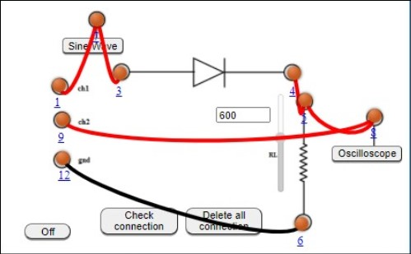

Full Wave Rectifier -

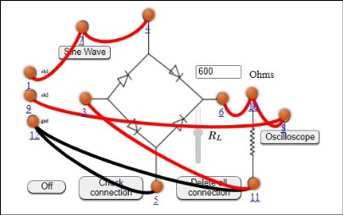

Capacitive Half Wave Rectifier -

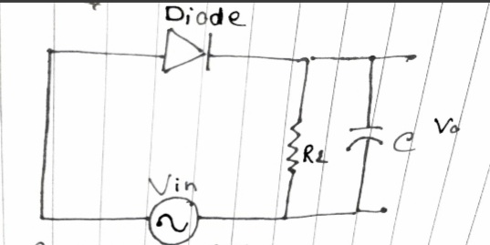

Capacitive Full Wave Rectifier -

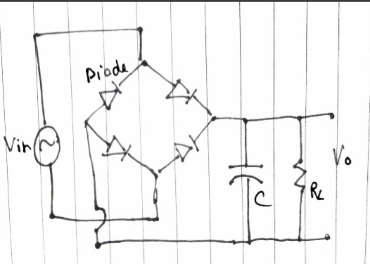

Zener Diode -

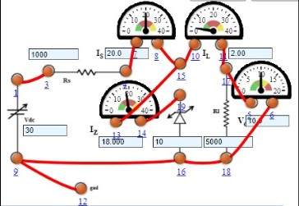

1. **Measurement Data (Tabular form)**

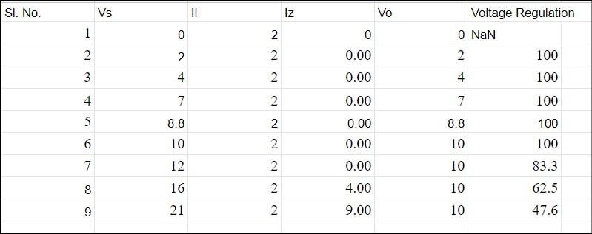Zener Diode-Line Regulation

Zener Diode-Load Regulation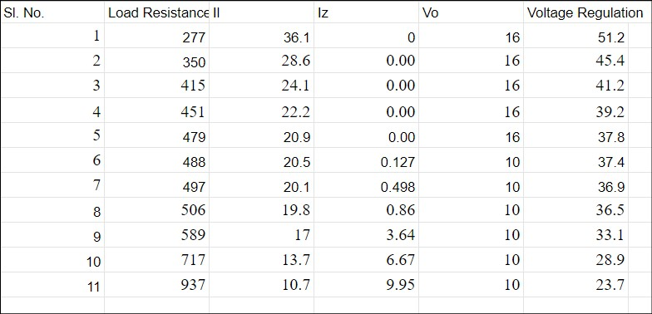

1. **Graph (Image)/Screenshots**

Half Wave Rectifier -

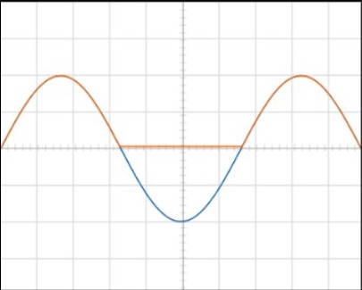

Full Wave Rectifier -

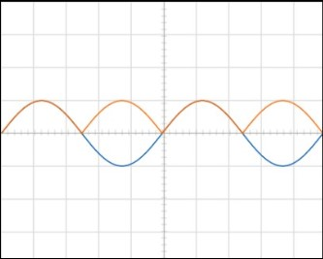

Capacitive Half Wave Rectifier -

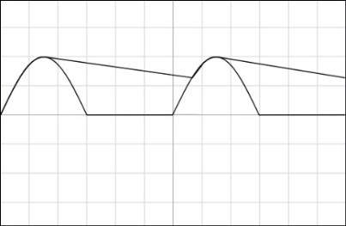

Capacitive Full Wave Rectifier -

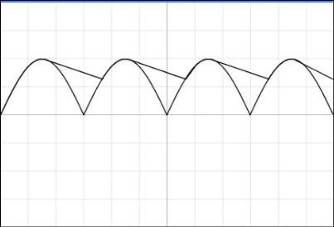

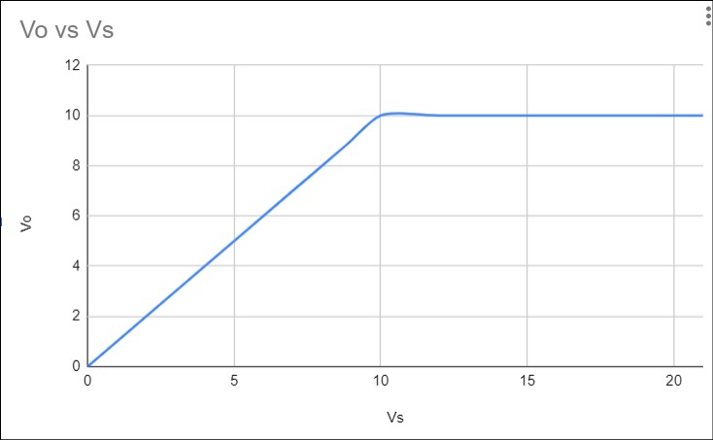Zener Diode-Line Regulation

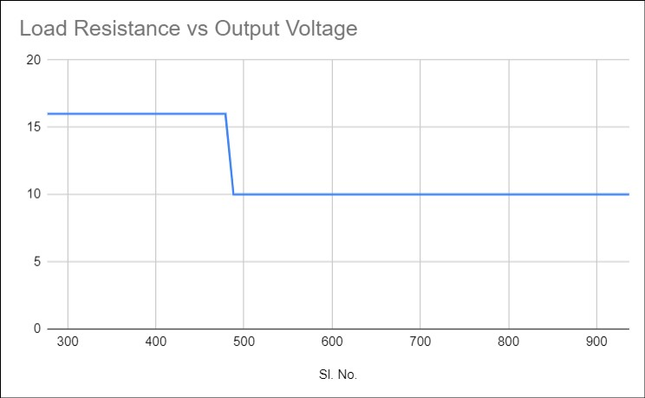Zener Diode-Load Regulation

1. **Calculations**

**Ripple factor** is a measure of effectiveness of a rectifier circuit. It is defined as the ratio of RMS value of the AC component (ripple component) Irrms in the output waveform to the DC component VDC in the output waveform.

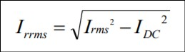

For half wave rectifier,

Irms = Im/2

IDC = Im/p

r = Irrms/ IDC

This leads to ripple factor r =1.21 for half wave rectifier.

For a half wave rectifier with filter capacitor, ripple factor is given by,



Thus ripple factor comes out to be 0.05 for capacitive half wave rectifier.

For full wave rectifier :

r = Vrrms/ VDC

where Vrms = Vm/1.41 ; VDC = 2Vm/p

Ripple factor comes out to be 0.483

The ripple factor for full wave rectifier with capacitor filter is given by,

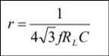

Thus ripple factor comes out to be 0.025 for capacitive full wave rectifier.

1. **Conclusion**

We were able to verify the theoretical principles of rectifiers and diodes in this experiment. We observed that in case of half-wave rectifiers, only the +ve part of the input signal was allowed to pass through and the rest of it was blocked. Whereas, in the case of full-wave rectifiers, complete input signal was allowed to pass through and both parts were transformed to the same polarity. Using a capacitor as a filter helped to smoothen out the output signal, reducing the ripple effect. Finally, using a Zener diode in a voltage regulated DC circuit, we were able to observe the properties of a Zener diode and it’s behaviour in the break-down region. The output voltage for Zener Diode - Line Regulator became constant and was equal to the Zener voltage, for all input values greater than or equal to the Zener voltage. All this behaviour is a result of the special property of semi conductor diodes which allows current to flow when forward biased but not as easily when reverse biased.

1. **Discussions**

The primary application of rectifiers is to derive DC power from an AC supply (AC to DC converter). Rectifiers are used inside the power supplies of virtually all electronic equipment. Rectifiers are used in mobile and laptop chargers, TVs, kitchen appliances, car alternators and in many more areas.To smoothen the output wave form filters are used here we have used capacitors. If the capacitor value is very low, there will be huge ‘gaps’ and the ripple effect will be much more prominent. However, for large enough values of capacitors, the output signal will be much more smoothened out and the observed ripple effect will be reduced. Ripple Factor is inversely proportional to Capacitor Value in case of capacitive circuits. Zener Diode Voltage Regulator have thinner depletion region. When we apply a voltage more than the Zener breakdown voltage (can range from 1.2 volts to 200 volts), the depletion region vanishes, and large current starts to flow through the junction. Also, Zener diodes are bi-directional whereas, normal p-n junction diodes are uni-directional.